10 ways to help you kick start your 2018 fitness goals right now

Everyone loses the motivation to work out once in a while.
We may wish it wasn't so, but we all get to the point where the thought of exercising seems more dreadful than exciting. The dread then manifests itself in a series of excuses we tell ourselves when the alarm goes off on our designated exercising days.
Once the thought of working out makes you unhappy, you're fighting an uphill battle. But how can you make yourself happy to work out again?
There's no "right" answer because different things work for different people, but there are a few things worth trying. Sometimes all it takes to break through a rut is trying something new.
If you no longer have beach body motivations to keep you going, or you're just plain burned out, try one of these tactics to avoid hitting the "quitting point".
Below are 10 ways you can stay motivated and accomplish your fitness goals.

Start a workout log
The easiest way to stay motivated is by having concrete goals. Vague ones like wanting to "look better" or "be healthier" lead to vague workouts. "Being healthier" can mean working very hard one day, then relaxing for two. Having a set goal will force you to work towards something specific, which is why it's better to plan on running a 5K instead of deciding to "run more".
Once you have your goal, the next step is to plan out how you'll achieve it. Many people swear by digital workout diaries, but in my experience the only reliable way to keep a workout log is to have a physical copy staring me in the face.
A workout diary gives you a way to create a roadmap to success and keep a record of what did and didn't work if you fall short. If accountability has been your problem, this small book can be a big help.

Workout from home
A huge part of staying motivated to work out is making it convenient. It's easy to go to the gym/class when you have time, but if you have a long commute or have to stay late at work, it can be difficult to make a gym/class happen.
You might think the best way to combat this is to wake up earlier, but while that does add hours to your day, shorting yourself sleep is hard to sustain and can impact your performance. Work out at home is a better solution, and when done right it's as strenuous as a visit to the gym. Do what works best for you!

Get a Personal Trainer
Wanting to work out and knowing what to do are two very different things. Sometimes it's hard to know where to get started, which leads to aimlessly wandering around the gym. A Personal Trainer will help you to make the best of your workouts. They will help motivate you and point you in the right direction achieve those fitness goals

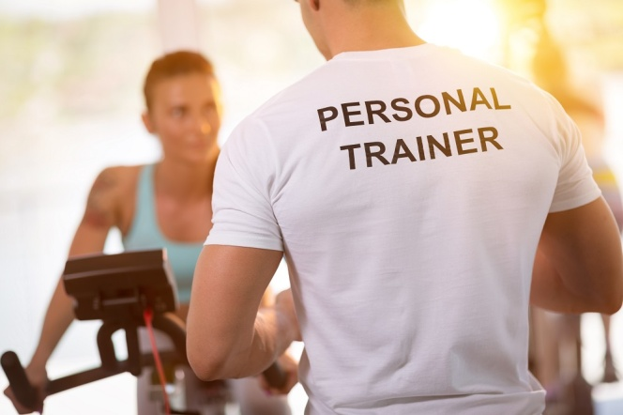

Throw some music into your workout
It's hard to deny that the right music can have an impact on both your motivation and performance. We have all experienced a class that has fantastic music that totally transforms the way you perform, or sadly the opposite when you just want the class to finish!!
Regardless of your taste, there's value in integrating your personal favourites with your workouts.

Build a team around you
Sometimes you'll need to rely on others to help motivate you to get moving. Yes we can have our family and friends as a support network, but thanks to social media you don't just need to rely on them. You can connect to a whole fitness community and contact people experiencing the same things as you and share your workouts.
Apps like Nike+ and Fitbit can both record your workouts and help you connect with other people trying to get in shape.
Using Facebook, Pump up and Instagram, you can choose who to follow and who can follow you. You're able to post workouts, inspirational quotes, and pictures to motivate the community around you and surround yourself with motivated people.

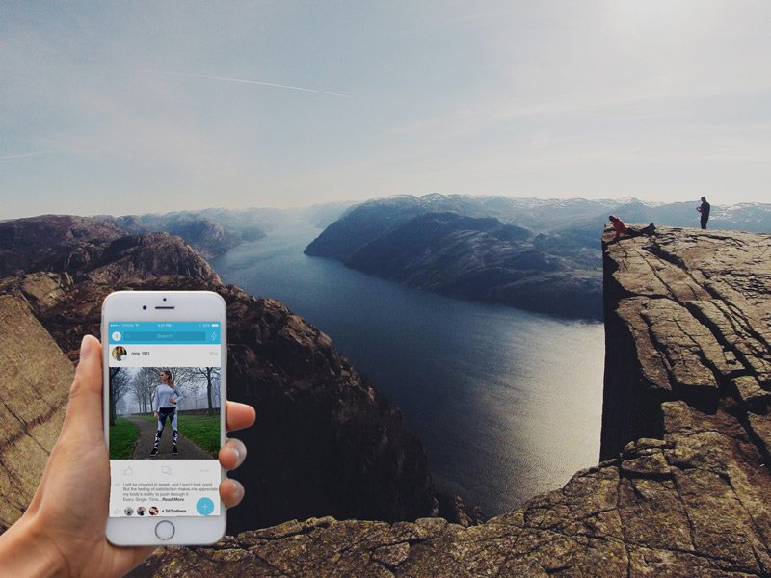

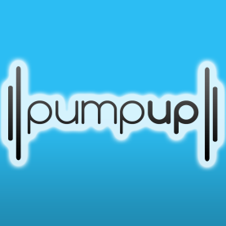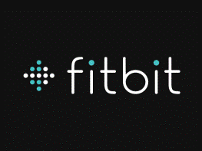

Take better care of your body
Nothing can kill your love of exercise like getting hurt. Runners deal with shin splits, lifters combat joint pains, and swimmers over-use their shoulders. Injuries are the quickest way to quit working out so if you want to keep at it, make sure you prevent that pain. When you set out your workout days make sure that you incorporate REST days too.
. 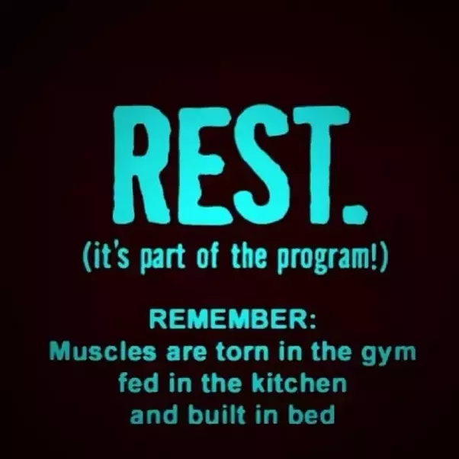

Start your day right
When you burn more calories than you consume, you lose weight. When you eat breakfast, you activate the thermogenesis process and thus stimulate your metabolism. Plus, studies have shown that eating a meal in the morning boosts your metabolism more than eating the same meal in the evening…. After all you wouldn’t expect to drive your car without any fuel! So why ask your body to work out on a empty stomach!

Reward yourself
Reward systems are often the best way to incentivize a work out. There are a variety of ways to do this but set out a plan, and treat yourself when you achieve one of your goals!

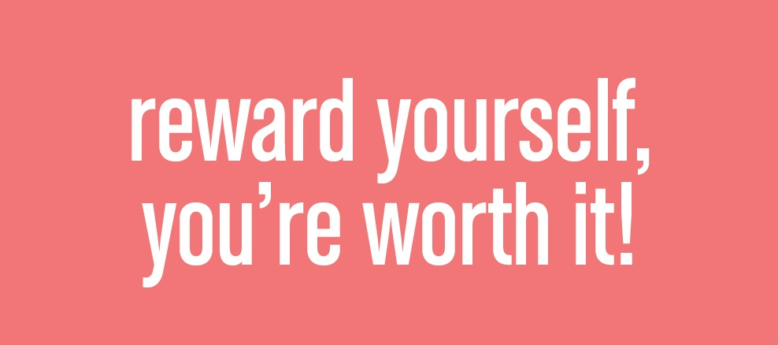

Dress the part
Crazy as it may sound, wearing some nice gym clothes can increase your desire to exercise. If this works for you, then change into your gym clothes once you get home and let them take you the rest of the way.

Workout with a friend
The benefits of a workout buddy are endless. Here are three valid reasons:
- With a buddy it's more fun, you're going to do it more, stick with it longer and in the end you'll get better results.
- This person is counting on you to be on track with them. It makes you more accountable in regards to proper eating habits.
- You're planning your workouts in advance and making sure you are there for your buddy and for yourself.
