Question….
“Why do I find it’s getting harder each week?”, when I am doing my usual Group Fitness Class or Workout?
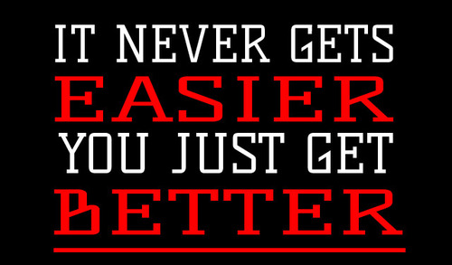

I am often asked in my group exercise classes, “Why is it that I STILL find it hard when I am definitely feeling fitter”? There is a very good answer to this and I am going to try to explain the reasons why.
Having spent the last 28 yrs teaching Group Fitness Classes at various Health Clubs, Leisure Centres and halls I have witnessed many things in my time, good & bad!
The job of a Group Fitness Instructor covers many roles. Over the years I have experienced many examples of great teaching, and have worked alongside some of the best, but unfortunately some poor ones too!
So to answer the question above I am going to try to break these roles down, so you can understand and hopefully next time a class starts to feel harder than last time you will not blame yourself !!

Benefits of Group Exercise
Most people know exercise is good for them and want to begin exercising. However, they do not know the first step to take. They are bombarded with urgent messages from the media to exercise, but receive little guidance on how to initiate that process. This can be a very overwhelming task, especially when our lives are hectic.

Group exercise offers a workout for all levels, ranging from beginner to advanced. Participants do not need to know how to develop a safe and effective workout or which machines to use or for how long; it is already done for them. They simply have to show up with a positive attitude, participate, and most importantly, have fun.
An exercise class structured with a purpose can be beneficial for people with limited knowledge about safe and effective exercise programming. An appropriately designed class includes warm-up, cool-down and flexibility in addition to the conditioning section. When people exercise on their own, they often skip portions of a workout they know less about or are not their favourite to perform. Furthermore, the fitness professional is not only designing the components of the workout, but also the intensity, so the class is designed appropriately to improve cardio respiratory and muscular fitness.

A common reason for quitting an exercise program is boredom. A variety of class formats will keep you motivated and interested, as well as give you different instructor styles, music selection, and interaction with other participants. For many, an hour-long workout goes by very quickly when there is music playing and you are trying new exercises. People stay interested because of the social atmosphere provided by group exercise. This offers camaraderie and accountability among participants, as well as between participants and instructor.
The role of the Fitness Instructor is not only to provide all of the above to ensure you return each week, but to monitor, evaluate and ensure their members progress. This enables them to change and ‘tweak’ your exercise programme, so they ensure that their members see improvements in their performance and fitness levels. When this happens this is where a lot of people start to ask the question, “Why do I find it’s getting harder this week?”
And the answer is that a good experienced Fitness Instructor will always be monitoring and evaluating their class, and will adapt the workout accordingly. This will then not only keep the format of the class fresh, but also ensure that the class members will start to improve in their overall fitness. Muscles have a great memory! They get used to an exercise that is repeated time and time again, so changing the format ensures that the muscles are challenged and working efficiently at all time.
So next time you are in a class and you are thinking to yourself… “God this is hard this week”…. It will properly be that the Instructor has evaluated the class and has made changes to challenge you to reach the next level of Fitness.

