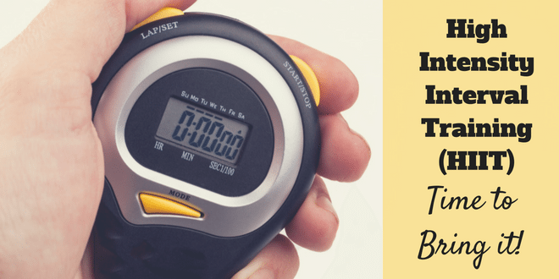
March 2019 - HITT

Lower/Upper Body & Abs/Back Workout
4min warm 20sec on each exercise repeat twice though
- Forward jog and backwards- 4 forward 4 back
- Kick backs
- Basic squats
- Reverse lunge + knee lifts L & R

HIIT Workout 20min
20sec - work / 10sec – rest repeat 4 sets of each exercise (15)
- Wide Sumo Squat + Lateral raisers using weights
- Repeater Knee lifts L & R alternate using weights
- Squats forward shoulder raises using weights
- Sit ups feet on floor
- Reach over’s feet off hands come down to floor
- Burpees with 4 x jacks up – repeat – Alternative – Wide squat, reverse wide lunge, squat, repeat fast
- Jogging climbing a rope using weights
- Tricep overhead extensions using weights
- On all fours alternate L arm, R leg extensions, slow & fast
- Back extensions on individual levels
- Criss Cross adductors
- Shuffle - Shuffle - tap
- Power Lunges - forward L & R alternate using weights
- Bowlers L & R using weights with overhead reach
- Downdog knee drops slow & up tempo

Stretch – D/Dog, Resting Child’s Pose, Bridge, Cat, Pigeon, repeat on other side

