‘Bingo wings’...and how to banish them for summer
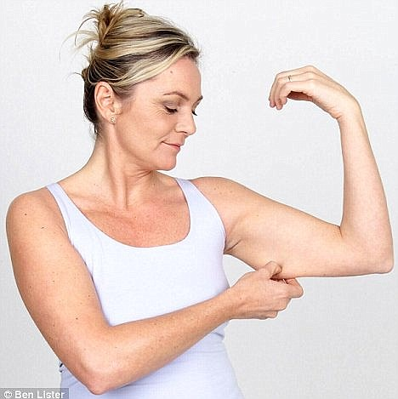
‘Bingo wings’ is a slang term used to describe folds of loose flesh or skin hanging from the undersides of a person's upper arms (over the triceps). It occurs most frequently as we get older and overweight people.
The term apparently originated in 1990's from an association with the game of bingo, in which the loose flesh may be visible when a winner calls out and raises their hand to signal a win.
SO….If you're secretly quite pleased that the sunshine has gone missing this year because you haven’t had to bare your upper arms, help may be at hand.
Bingo wings – no-one wants them, but there they are, jiggling away. If you find yourself clamping your arms to your side because your upper arms are a little wobbly, or reaching for a jacket every time you go out to cover your arms, then it’s time to tighten and tone the skin and muscles with this quick and simple workout routine.
Targeting the stubborn area of the upper arm, I’ve chosen five moves that’ll strengthen, shape and sort that wobble out for good.
I am frequently asked “How can I tone up my upper arms?” The answer is not only having a healthy diet, resulting in reducing your body fat, but exercising, strengthening and toning the muscles i.e. Triceps, biceps, shoulders (Deltoids) and chest (Pectorals). There is NO quick fix and it won’t happen overnight. BUT following these exercises in time you will start to see a difference. These exercises are so easy to do that you can do them in your living room or even while you’re on holiday or away on business, and take around five minutes.
In a ideal world I would recommend following this workout every day for excellent toning - and with summer coming, there's no better time to start, but realistically 3-5 times a week will be fine.
Why not work them into your daily routine by doing them while you wait for the kettle to boil, or while watching your favourite soap in the evening?
They’ll also help to build your upper body strength up and help to make you feel more confident next time you want to wear short sleeves!!

The 5 easy to follow exercises – 10-15 reps of each exercise repeating 3 times

TRICEP DIPS - Follow these steps to perform this exercise:
- Position your hands shoulder-width apart on a secured bench or stable chair.
- Slide your butt off the front of the bench with your legs extended out in front of you.
- Straighten your arms, keeping a little bend in your elbows to keep tension on your triceps and off your elbow joints.
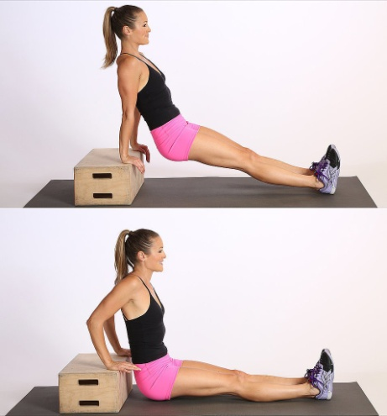

TRICEP PUSHUPS - Follow these steps to perform this exercise:
1. Get in plank position with your hands shoulder-width apart , on toes or knees.
2. Lower your chest toward the floor while keeping your upper arms parallel to your sides and your elbows pointing straight back
3. Push back up to start.
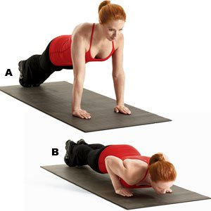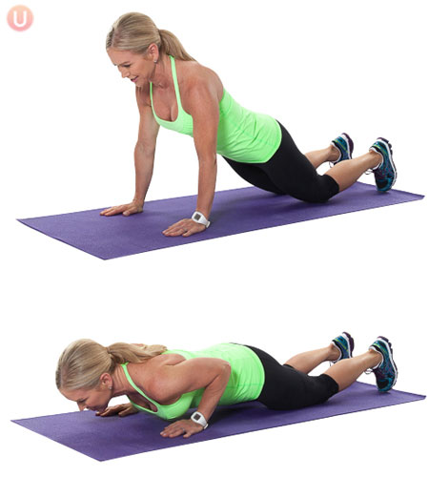

PRESS UPS - Follow these steps to perform this exercise:
1. Get into a plank position on toes or knees. Place your hands firmly on the ground, directly under shoulders. Ground your toes into the floor to stabilize your lower half, or drop onto your knees. Brace your core (tighten your abs as if preparing to take a punch), engage glutes and hamstrings, and flatten your back if on your toes, so your entire body is neutral and straight.
2. Lower your body. Begin to lower your body—keeping your back flat and eyes focused about three feet in front of you to keep a neutral neck—go as low as you can. Don’t let your butt dip or stick out at any point during the move. Draw shoulder blades back and down.
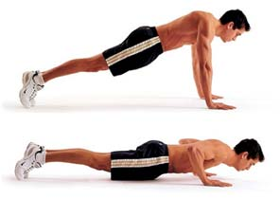
3. Pushing back up! Keep your core engaged; exhale as you push back to the starting position. Tip: Imagine you are screwing your hands into the ground as you push back up.

Dumbbell Shoulder Press - Follow these steps to perform this exercise
- Hold a dumbbell (or use filled water bottles if you don’t have dumbbells) in each hand and sit on a bench/seat with back support.
- Plant your feet firmly on the floor about hip-width apart.
- Bend your elbows and raise your upper arms to shoulder height so the dumbbells are at ear level.
- Now push the weight straight up exhaling as you push up and inhale as you come back down.
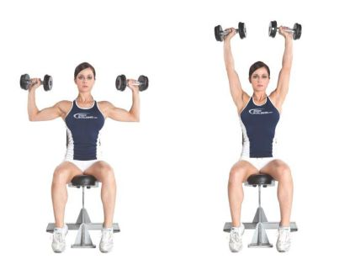

LATERAL RAISES - Follow these steps to perform this exercise:
1. Grasp dumbbells or water bottles in front of thighs with elbows slightly bent.
2. Bend over slightly with hips and knees bent slightly.
3. Raise upper arms to sides until elbows are shoulder height. Maintain elbows' height above or equal to wrists.
