April 2019 – HITT

Full Body Body & Abs Blast Workout

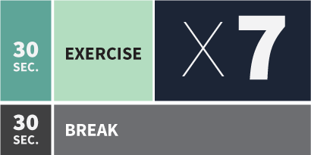

Warm-up - 30sec Work x 2 Sets
- Fast heel kick backs on spot
- Side Lunges L-R, stand tall in-between
- Squat Reaches
- Low reverse lunge up to high knee lifts L & R

30sec Work – 30sec Rest x 3 Sets
- Fast, High Knee March, opposite elbows to knees
- Star Jumps, arms over head OR fast side L-R lunges
- Parallel Squats, Thighs parallel with floor
- Box Push-ups or on toes
- Slow Motion Burpees, hands on floor step back, step in, stand up and repeat, or full Burpees
- Fast Jog on the spot
- Alternative leg on each set – Reverse Lunge bring knee up high touching with hands (DO 4 sets)

Abs Blast –

30sec Work – 30sec Rest x 2 Sets
- Sit ups feet on floor
- Sit Ups lifting knee to opposite elbow alternate L-R
- Knees to chest – Arms on floor, shoulders stay off
- Twisting Sit-ups, alternate L-R
- Reach over’s feet on or off floor, hands come down to floor
- Straight Leg Reach-ups off the floor
- Forearm Plank Knee to elbows on knees or toes

