The importance of ‘Stretching’

Especially as we get ‘Older’!
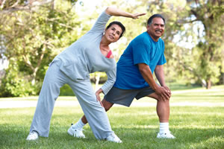

It's not enough to build muscle and achieve aerobic fitness. You need to think about flexibility, too.
You may think of stretching as something performed only by runners or gymnasts. But we all need to stretch in order to protect our mobility and independence. A lot of people don't understand that stretching has to happen on a regular basis. It should be part of your weekly workout routine and not an afterthought and here’s why….
Since becoming a ‘Piyo’ instructor I have found that stretching my muscles far more in all my classes each week, I have dramatically increased my flexibility and ROM, and have had fewer if NO injuries over the last year and a half, not bad now I am 54!!. Stretching keeps the muscles flexible, strong, and healthy, and we need that flexibility to maintain a range of motion in the joints. Without it, the muscles shorten and become tight. Then, when you call on the muscles for activity, they are weak and unable to extend all the way. That puts you at risk for joint pain, strains, and muscle damage.
An example of this is if you sit in a chair all day this can result in tight hamstrings in the back of the thigh. That can make it harder to extend your leg or straighten your knee all the way, which inhibits walking. Likewise, when tight muscles are suddenly called on for a strenuous activity that stretches them, such as playing tennis or during an exercise class, they may become damaged from suddenly being stretched. Injured muscles may not be strong enough to support the joints, which can lead to joint injury.
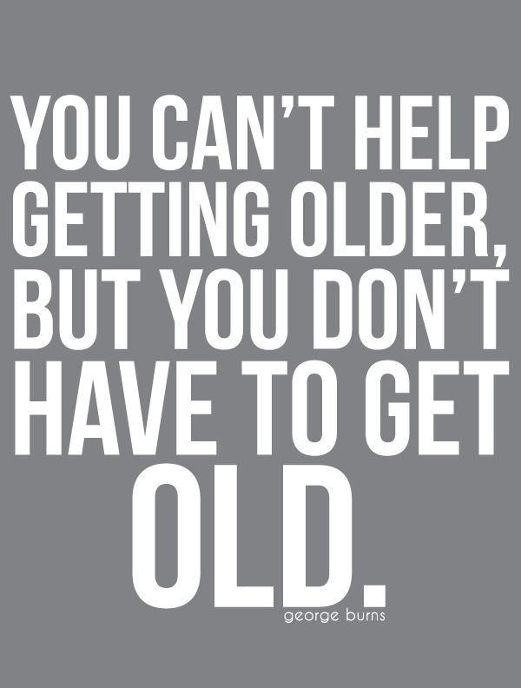
Regular stretching as we get older keeps muscles long, lean, and flexible, and this means that exertion won't put too much force on the muscle itself. Healthy muscles also help a person with balance problems to avoid falls and reduce the risk of injury and keep their independence for longer.
As we age, our muscles become shorter and lose their elasticity. Senior citizens begin slowing down their movements and even give up their regular routines to avoid injury and falls as their bodies get weaker. In some cases, seniors become unable to walk due to disease or loss of strength. Stretching is an important part of senior’s flexibility and will help offset the effects of normal decline in the flexibility of your joints, and help you remain active and independent. It is extremely important to keep muscles strong, even when one cannot walk or move for long periods of time. This is where stretching for seniors carries the most benefits.
When the body doesn’t move, it only gets weaker. Muscles get smaller and basic movements become impossible, as well as, joint pain that some seniors suffer on a daily basis. But when stretching is added to your life, you’ll feel better and joint problems will improve. Stretching can also improve blood circulation, reduce symptoms of disease and give you an overall feeling of wellbeing. Stretching especially can benefit those suffering from Arthritis, Parkinson’s, and Multiple Sclerosis.

Where to start
With a body full of muscles, the idea of daily stretching may seem overwhelming. But you don't have to stretch every muscle you have. The areas critical for mobility are in your lower extremities: you’re calves, hamstrings, hip flexors in the pelvis and quadriceps in the front of the thigh. Stretching your shoulders, neck, and lower back is also beneficial. Aim for a program of daily stretches or at least three or four times per week.
Find a class you can assess, or talk to a trainer about your muscle strength and can tailor a stretching program to fit your needs. If you have chronic conditions such as Parkinson's disease or arthritis, you'll want to clear a new stretching regimen with your doctor before you start.
A hamstring stretch will keep the muscles in the back of your thigh flexible. Sit on the floor with your legs in front of you. Slide your hands down your legs until you feel a burning sensation. Hold for 30 seconds, then slowly return to a sitting position.

The cumulative effect of stretching
Stretching once today or two to three times a week won't magically give you perfect flexibility. You'll need to do it over time and remain committed to the process. It may have taken you many months to get tight muscles, so you're not going to be perfectly flexible after one or two sessions

Proper execution
We used to believe that stretching was necessary to warm up the muscles and prepare them for activity. However, mounting research has shown that stretching the muscles before they're warmed up can actually hurt them. When everything is cold, the fibres aren't prepared and may be damaged. If you exercise first, you'll get blood flow to the area, and that makes the tissue more pliable and amenable to change. All it takes to warm up the muscles before stretching is five to 10 minutes of light activity. You can also stretch after an aerobic or weight-training workout.
Hold a stretch for 30 seconds. Don't bounce, which can cause injury. You'll feel tension during a stretch, but you should not feel pain. If you do, there may be an injury or damage in the tissue. Stop stretching that muscle, and talk to your doctor.

Here are a few stretches that will start to help you improve the flexibility in the mobility are in your lower extremities; hamstrings, calves, hip flexors in the pelvis and quadriceps in the front of the thigh.
Hamstrings
Forward Bend with Rounded Back
A hamstring stretch will keep the muscles in the back of your thigh flexible. Sit on the floor with your legs in front of you. Slide your hands down your legs until you reach your full range of movement/stretch. Hold for 30 seconds, breathing out as you increase the stretch; slowly, and then return slowly to a sitting position, repeating 2-3 times.
Reclined Hamstring Stretch
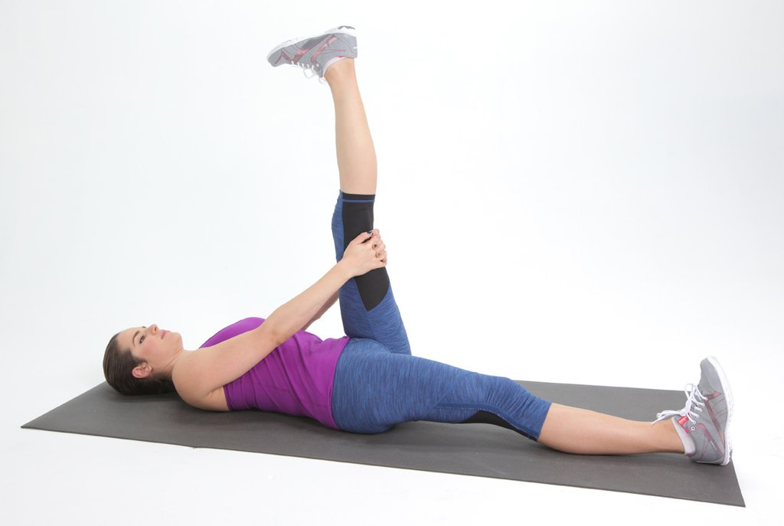

Here's a relaxing way to stretch one hamstring at a time.
- Lie on your back. Raise your left leg as high as you can keep your pelvis flat on the ground. Hold your lower thigh and encourage the leg to move toward your head. Flex your foot to stretch your calf too.
- To deepen the stretch, place a yoga strap or towel on the ball of your foot and use your hands to pull the strap toward you. After 30 seconds, switch legs. Repeat 2-3 times on each side.

Calves
Wall Calf Stretch
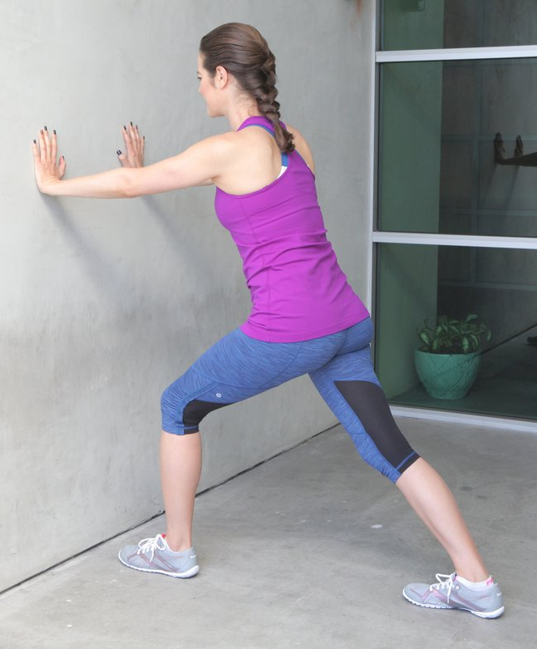
This is a classic calf stretch that you can do just about anywhere.
- Stand a little less than arm's distance from the wall.
- Step your left leg forward and your right leg back, keeping your feet parallel.
- Bend your left knee and press through your right heel.
- Hold for 20 to 30 seconds and switch legs.
- Repeat 2-3 times

Downward Facing Dog
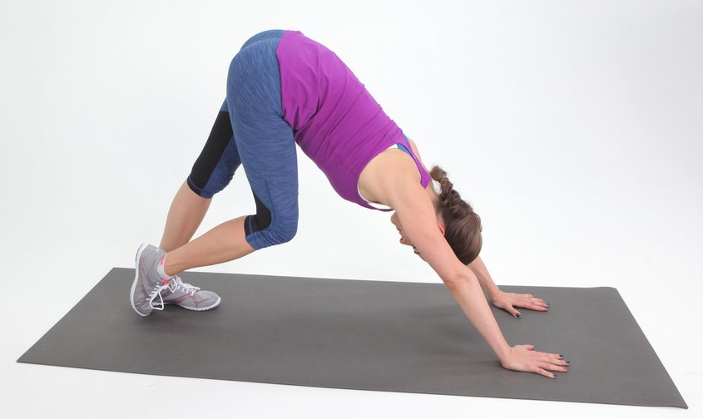
This basic yoga pose is a great calf stretch.
- Begin in a plank pose with your hands under your shoulders then lift your pelvis up making a "V" with your body. Spread your fingers wide and soften elbows and knees.
- Work on bringing your heels toward the ground.
- Allow your heels to flare out slightly wider than your toes
- Tilt your hips and tail bone/pelvis, high to the ceiling to increase the stretch.
- To deepen the stretch in your calves, try treading lightly by pressing down on one foot while bending your other leg (as shown). Hold a few seconds per leg and then switch.
- Hold or alternate your feet for a total of 30 seconds.
- Relax into child’s pose and repeat 2-3 times

Hip Flexor Stretch

The hip flexors, the muscles at the front of the hip, can become extremely tight just from sitting. This intense stretch targets that area as well as the outer hips.
- Come into a lunge position with your right knee forward. Lower your left knee to the floor, and rest your hands on the ground under your shoulders.
- Slowly lower your right knee to the right so you're resting on the outside of your right flexed foot. Keep your arms straight, pressing your chest forward to increase the stretch.
- Hold like this for five breaths, and then repeat on the left side

Quadriceps

Standing Quad Stretch
This basic quad stretch is probably one you're already familiar with. It's great because you can do it almost anywhere — you don't need a lot of space or equipment because you can do it right where you're already standing. Make sure your knees are touching when you do this stretch and hold on each side for 20-30 seconds. And, if you can't balance, don't worry — just use the wall to support yourself.

Lying Quad Stretch

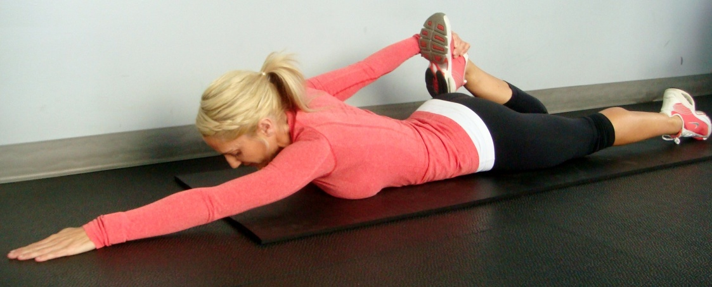

Sometimes during my Piyo practice, or while I'm in bed, I'll do this stretch. It's a bit more relaxing, and you don't have to worry about falling over! Try it the next time you're watching TV.

